SIMATS ENGINEERING
ASSESSMENT TOOL 1
COURSE NAME: COMPUTER ARCHITECTURE COURSE CODE: CSA12
COURSE OUTCOME COVERED
CO1: Analyze the functional units of a computer system including CPU, memory, bus structures, and I/O components by examining instruction execution cycles, addressing modes, and performance metrics such as CPI, clock cycles, and benchmarking (BL4) Assessment Tool Weightage: 40%
QUESTIONS:5 Total Marks:25
ANNEXURE A
APPLICATION BASED QUESTIONS
Code of Conduct:
I Deepthi Korrapati(192572012) (Name / Reg No) certify that this submission is my original work and that I have adhered to the guidelines specified for this assessment. I understand that any violation of academic integrity rules will result in disciplinary action.
Signature of the student:

ANNEXURE A
1. A smart city surveillance system processes continuous video feeds from multiple cameras, where large volumes of data are transferred between I/O devices, memory, and CPU. During peak hours, the system experiences lag and delayed response in threat detection. Analyze how the interaction between CPU, memory, and I/O contributes to this issue, and explain how different bus structures (single-bus vs multi-bus) and improvements in instruction execution cycle can enhance system performance.
2. A real-time stock trading application running on a processor executes millions of instructions per second, but users report delays in transaction processing during high load. The system has a high CPI due to frequent memory access and branch instructions. Examine how the fetch–decode– execute cycle impacts execution time in this scenario, and propose methods to reduce CPI and improve overall CPU performance using suitable architectural enhancements.
3. An embedded system based on an 8085 microprocessor is used in an industrial temperature control unit, where sensors provide input and actuators respond accordingly. However, incorrect temperature readings are occasionally processed due to improper use of addressing modes in the program. Discuss how different addressing modes influence data access, identify possible causes of such errors, and suggest how the instruction set of 8085 can be effectively used to ensure accurate and reliable operation.
4. A computing system uses an 8086 microprocessor with segmented memory for executing multiple programs simultaneously, but it encounters issues like incorrect data access and stack overflow errors. Evaluate how segmentation (code, data, and stack segments) works in 8086, analyze how improper segment handling can lead to such problems, and explain how instruction execution and addressing modes must be managed to ensure correct program execution.
5. A data communication system represents packet information in hexadecimal format for ease of debugging and transmission, but a software engineer mistakenly interprets values, leading to incorrect data processing. Analyze the importance of number system conversions between hexadecimal and binary in such systems, explain how errors in conversion can affect instruction execution, and discuss how efficient CPU design and benchmarking can help detect and minimize such issues in real-time systems.
MARKS ALLOCATION
Criteria | Understanding of Problem  Context (20%) | Application of Concepts  (20%) | Problem-Solving Approach (20%) | Accuracy of  Solution  (20%) | Clarity (20%)
Q1
Q2
Q3
Q4
Q5

RUBRICS FOR CALCULATION:
Criteria | Weightage | Level 4 –  Exemplary | Level 3 – Proficient | Level 2 –  Developing | Level 1 –  Beginning
Understan  ding of  Problem  Context | 20 | Clearly understands the problem and  accurately identifies all requirements | Good understanding with minor gaps | Basic  understanding; some  requirements unclear | Poor  understanding or misinterpretation of the problem
Application of Concepts | 30 | Accurately applies appropriate concepts to solve complex  problems | Applies relevant  concepts correctly with minor errors | Applies basic  concepts with limited  accuracy | Fails to apply  appropriate  concepts
Problem  Solving  Approach | 20 | Logical, well  structured, and  efficient approach | Mostly logical  approach with  minor gaps | Basic approach with some  inconsistencies | Illogical or unclear approach
Accuracy of Solution | 20 | Completely correct solution with proper justification | Mostly correct with minor errors | Partially  correct  solution | Incorrect or  incomplete  solution
Clarity | 10 | Clear, well  organized, and  properly explained solution | Understandable  with minor clarity issues | Limited clarity and  explanation | Poorly presented and difficult to  understand

Question 1
A smart city surveillance system processes continuous video feeds from multiple cameras, where large volumes of data are transferred between I/O devices, memory, and CPU. During peak hours, the system experiences lag and delayed response in threat detection. Analyze how the interaction between CPU, memory, and I/O contributes to this issue, and explain how different bus structures (single-bus vs multi-bus) and improvements in instruction execution cycle can enhance system performance.

Answer:
Introduction
A smart city surveillance system continuously receives video from multiple CCTV cameras. The video data is transferred through I/O devices to memory, where the CPU processes it to detect suspicious activities. During peak hours, the large amount of video data increases the workload on the CPU, memory, and communication bus, causing lag and delayed threat detection.

Interaction Between CPU, Memory, and I/O
CPU (Central Processing Unit)
- Executes instructions and processes video frames.
- Runs image processing and threat detection algorithms.
- Sends alerts when suspicious activity is detected.
Memory (RAM)
- Stores video frames and program instructions.
- Supplies data to the CPU for processing.
- Stores temporary results before output.
I/O Devices
- Input: CCTV cameras, sensors.
- Output: Monitor, alarm system, storage devices.
- Transfer video data between cameras, memory, and CPU.
During peak hours:
- Multiple cameras send data simultaneously.
- Memory receives many read/write requests.
- CPU waits for data from memory.
- This increases processing time and causes delays.

Single-Bus Structure
In a single-bus architecture, the CPU, memory, and I/O devices share one communication bus.
Advantages
- Simple design.
- Low cost.
- Easy to implement.
Disadvantages
- Only one data transfer can occur at a time.
- Bus contention occurs when many devices use the bus.
- CPU waits for memory and I/O operations.
- System performance decreases.

Multi-Bus Structure
In a multi-bus architecture, separate buses are provided for CPU, memory, and I/O communication.
Advantages
- Multiple data transfers occur simultaneously.
- Reduces bus contention.
- Faster communication between components.
- Improves overall system performance.
Disadvantages
- Higher cost.
- More complex hardware design.

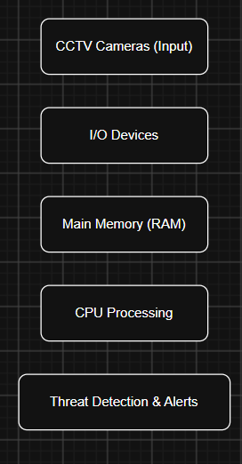
Comparison of Single-Bus and Multi-Bus
Feature | Single Bus | Multi Bus
Number of buses | One | Multiple
Data transfer | One at a time | Simultaneous
Speed | Lower | Higher
CPU waiting time | More | Less
Performance | Moderate | High

Instruction Execution Cycle
Every instruction executed by the CPU follows four stages:
1. Fetch
The CPU fetches the instruction from memory.
2. Decode
The Control Unit interprets the instruction.
3. Execute
The ALU performs arithmetic or logical operations.
4. Store
The result is written back to memory or sent to the output device.
If memory access is slow or the bus is busy, the CPU spends more time waiting, increasing execution time.

Methods to Improve Performance
- Instruction Pipelining: Executes multiple instructions simultaneously.
- Cache Memory: Stores frequently used data for faster access.
- DMA (Direct Memory Access): Allows I/O devices to transfer data directly to memory without CPU involvement.
- Multi-Core Processor: Processes multiple video streams in parallel.
- High-Speed RAM: Reduces memory access time.
- Branch Prediction: Minimizes delays caused by branch instructions.

Conclusion
The performance of a smart city surveillance system depends on efficient communication between the CPU, memory, and I/O devices. Heavy data transfer during peak hours causes bus congestion and CPU waiting, leading to delayed threat detection. Using a multi-bus architecture, along with cache memory, pipelining, DMA, and multi-core processors, improves data transfer speed, reduces delays, and enables faster real-time surveillance.

Question 2
A real-time stock trading application running on a processor executes millions of instructions per second, but users report delays in transaction processing during high load. The system has a high CPI due to frequent memory access and branch instructions. Examine how the fetch–decode–execute cycle impacts execution time in this scenario, and propose methods to reduce CPI and improve overall CPU performance using suitable architectural enhancements.
Answer:

Introduction
A real-time stock trading application processes millions of buy and sell transactions every second. The processor must execute instructions quickly to complete transactions without delay. During high trading activity, the CPU experiences a high CPI (Cycles Per Instruction) due to frequent memory access and branch instructions, resulting in slower execution and delayed transaction processing.


Fetch–Decode–Execute Cycle
The CPU executes every instruction through the following stages:
1. Fetch
- The CPU fetches the next instruction from main memory using the Program Counter (PC).
- If memory access is slow, the CPU must wait before fetching the instruction.
2. Decode
- The Control Unit decodes the instruction.
- It determines the operation to be performed and identifies the required operands.
3. Execute
- The Arithmetic Logic Unit (ALU) performs arithmetic or logical operations.
- If the instruction requires memory access, additional clock cycles are needed.
4. Store (Write Back)
- The result is stored in a register or memory.
- The CPU then proceeds to the next instruction.

Impact on Execution Time
During high load:
- Millions of instructions are executed every second.
- Frequent memory access increases waiting time.
- Branch instructions interrupt the normal flow of execution.
- Cache misses force the CPU to access slower main memory.
- Pipeline stalls occur due to branch instructions.
These factors increase CPI, resulting in longer execution time and slower transaction processing.

Causes of High CPI
- Frequent access to main memory.
- Cache misses.
- Branch instructions causing pipeline stalls.
- Data dependencies between instructions.
- Slow memory access speed.

Methods to Reduce CPI
1. Use Cache Memory
- Frequently used instructions and data are stored in cache.
- Reduces memory access time.
- Decreases CPU waiting time.
2. Instruction Pipelining
- Multiple instructions are processed simultaneously in different stages.
- Increases instruction throughput.
- Improves CPU utilization.
3. Branch Prediction
- The processor predicts the outcome of branch instructions.
- Reduces pipeline stalls.
- Improves execution speed.
4. Out-of-Order Execution
- The CPU executes independent instructions while waiting for slower instructions.
- Reduces idle time.
- Improves processor efficiency.
5. Multi-Core Processor
- Different cores execute different tasks simultaneously.
- Allows parallel processing of multiple transactions.
- Increases system performance.
6. Increase Memory Bandwidth
- Faster RAM improves data transfer between memory and CPU.
- Reduces memory latency.

Architectural Enhancements
To improve CPU performance, the following enhancements can be used:
- Larger L1, L2, and L3 cache memory.
- Superscalar architecture to execute multiple instructions in one clock cycle.
- Pipeline optimization to reduce execution delays.
- High-speed RAM for faster memory access.
- Multi-core processors for parallel execution.
- Prefetching to load instructions before they are needed.

Performance Formula
The CPU execution time is given by:
CPU Execution Time = Instruction Count × CPI × Clock Cycle Time
To improve performance:
- Reduce the Instruction Count by writing optimized programs.
- Reduce CPI using cache memory, pipelining, and branch prediction.
- Reduce Clock Cycle Time by using faster processors.

Conclusion
The fetch–decode–execute cycle directly affects the performance of a real-time stock trading system. Frequent memory access and branch instructions increase CPI, causing transaction delays during heavy workloads. Using cache memory, instruction pipelining, branch prediction, out-of-order execution, multi-core processors, and high-speed memory reduces CPI and improves CPU performance, enabling faster and more reliable transaction processing.

Question 3
An embedded system based on an 8085 microprocessor is used in an industrial temperature control unit, where sensors provide input and actuators respond accordingly. However, incorrect temperature readings are occasionally processed due to improper use of addressing modes in the program. Discuss how different addressing modes influence data access, identify possible causes of such errors, and suggest how the instruction set of 8085 can be effectively used to ensure accurate and reliable operation.
Answer:
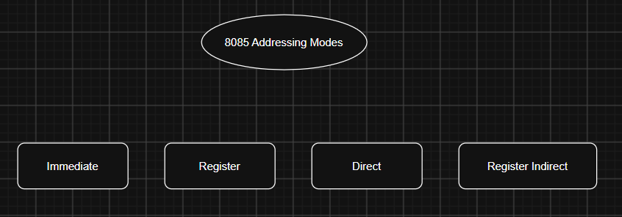

Introduction
An 8085 microprocessor is widely used in embedded systems such as industrial temperature control units. It receives temperature data from sensors, processes the information, and controls actuators like heaters or cooling fans. If the program uses incorrect addressing modes, the processor may access the wrong data, leading to incorrect temperature readings and improper system operation.

Addressing Modes in 8085
Addressing modes determine how the processor accesses data during instruction execution.
1. Immediate Addressing Mode
- The data is directly included in the instruction.
- It is mainly used for fixed values or constants.
Example:
MVI A,25H
2. Register Addressing Mode
- Data is stored in the processor registers.
- It provides fast execution because no memory access is required.
Example:
MOV A,B
3. Direct Addressing Mode
- The memory address of the data is specified in the instruction.
- Suitable for accessing fixed memory locations.
Example:
LDA 2500H
4. Register Indirect Addressing Mode
- The memory address is stored in a register pair (HL).
- The processor accesses data through the address stored in the registers.
Example:
MOV A,M

Influence of Addressing Modes on Data Access
- Immediate Addressing provides quick access to constant values.
- Register Addressing offers the fastest execution because data is already inside the CPU.
- Direct Addressing is useful for fixed sensor memory locations.
- Register Indirect Addressing is suitable for accessing arrays or changing memory locations.
Selecting the correct addressing mode ensures that the processor reads the correct sensor data and performs accurate operations.

Possible Causes of Incorrect Temperature Readings
- Using the wrong memory address to read sensor data.
- Incorrect initialization of the HL register pair.
- Using an inappropriate addressing mode.
- Programming errors in the instruction sequence.
- Corrupted or overwritten memory locations.
- Faulty sensor input or incorrect data transfer.
These issues may cause the processor to read invalid values, leading to incorrect temperature control.

Using the 8085 Instruction Set Effectively
The following instructions help ensure reliable operation:
- LDA – Loads temperature data from memory.
- STA – Stores processed temperature values.
- MOV – Transfers data between registers.
- MVI – Loads constant values into registers.
- CMP – Compares the measured temperature with the desired value.
- JZ, JC, JNZ – Performs decision-making based on comparison results.
- IN – Reads data from input devices such as sensors.
- OUT – Sends control signals to actuators.
Proper use of these instructions improves the accuracy of the temperature control system.

Methods to Ensure Accurate Operation
- Use the correct addressing mode for each instruction.
- Initialize registers before accessing memory.
- Verify sensor data before processing.
- Store sensor values in fixed memory locations.
- Test and debug the program regularly.
- Use proper branching instructions for decision-making.

Conclusion
In an 8085-based temperature control system, addressing modes play an important role in accessing data correctly. Improper use of addressing modes can result in incorrect sensor readings and unreliable system performance. By selecting the appropriate addressing mode and using the 8085 instruction set correctly, the system can process temperature data accurately, control actuators efficiently, and ensure reliable industrial operation.

Question 4
A computing system uses an 8086 microprocessor with segmented memory for executing multiple programs simultaneously, but it encounters issues like incorrect data access and stack overflow errors. Evaluate how segmentation (code, data, and stack segments) works in 8086, analyze how improper segment handling can lead to such problems, and explain how instruction execution and addressing modes must be managed to ensure correct program execution.
Answer:
Introduction
The 8086 microprocessor uses a segmented memory architecture to access up to 1 MB of memory. Memory is divided into different segments such as Code Segment (CS), Data Segment (DS), Stack Segment (SS), and Extra Segment (ES). Segmentation allows multiple programs and data to be managed efficiently. However, improper handling of segments can lead to incorrect data access, stack overflow, and program execution errors.
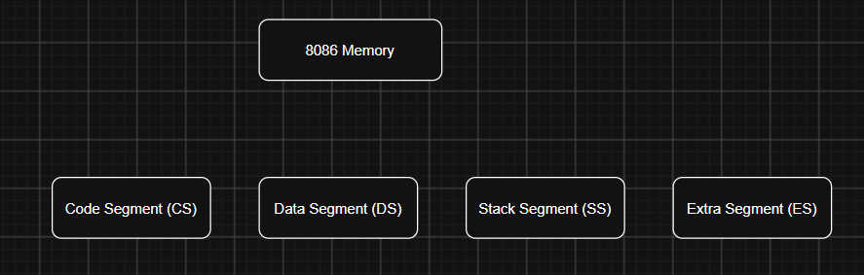

Segmentation in 8086
1. Code Segment (CS)
- Stores the program instructions.
- The CPU fetches instructions from the Code Segment.
- It works together with the Instruction Pointer (IP).
Function: Executes program instructions.

2. Data Segment (DS)
- Stores variables, constants, and program data.
- Most data access instructions use the DS register.
Function: Stores and retrieves program data.

3. Stack Segment (SS)
- Stores temporary data, return addresses, and local variables.
- Works with the Stack Pointer (SP).
Function: Supports function calls and subroutine execution.

4. Extra Segment (ES)
- Provides an additional data segment.
- Mainly used in string operations.
Function: Stores extra data required by the program.

Physical Address Calculation
The 8086 calculates the physical address using:
Physical Address = Segment × 16 + Offset
This method allows the processor to access 1 MB of memory using 16-bit registers.

Problems Due to Improper Segment Handling
Incorrect management of segment registers can cause several problems:
- Accessing the wrong memory location.
- Data corruption.
- Incorrect program execution.
- Stack overflow due to excessive PUSH operations.
- Stack underflow due to incorrect POP operations.
- Program crashes and unexpected results.
For example, if the DS register points to the wrong segment, the processor reads incorrect data instead of the required variable.

Instruction Execution in 8086
The instruction execution cycle consists of four stages:
1. Fetch
- The CPU fetches the instruction from the Code Segment (CS) using the Instruction Pointer (IP).
2. Decode
- The Control Unit decodes the instruction and identifies the required operation.
3. Execute
- The processor performs arithmetic, logical, memory, or control operations.
4. Store
- The result is written back to memory or registers.
Proper execution depends on correct values in the segment registers.

Addressing Modes in 8086
The 8086 supports several addressing modes for accessing data.
1. Immediate Addressing
- Data is directly present in the instruction.
2. Register Addressing
- Data is stored in CPU registers.
3. Direct Addressing
- The instruction contains the memory address of the data.
4. Register Indirect Addressing
- The memory address is stored in a register.
5. Based and Indexed Addressing
- Used for accessing arrays, strings, and complex data structures.
Using the correct addressing mode ensures that the processor accesses the intended memory location.

Methods to Ensure Correct Program Execution
- Initialize CS, DS, SS, and ES correctly before execution.
- Use the correct addressing mode for data access.
- Maintain proper stack operations using PUSH and POP instructions.
- Avoid stack overflow by monitoring the Stack Pointer (SP).
- Validate memory addresses before accessing data.
- Test programs thoroughly to detect segment-related errors.

Conclusion
The 8086 segmented memory architecture improves memory organization by dividing memory into code, data, stack, and extra segments. Improper handling of segment registers can lead to incorrect data access, stack overflow, and program failures. By correctly managing segmentation, using appropriate addressing modes, and following the proper instruction execution cycle, programs can execute accurately.

Question 5
A data communication system represents packet information in hexadecimal format for ease of debugging and transmission, but a software engineer mistakenly interprets values, leading to incorrect data processing. Analyze the importance of number system conversions between hexadecimal and binary in such systems, explain how errors in conversion can affect instruction execution, and discuss how efficient CPU design and benchmarking can help detect and minimize such issues in real-time systems.
Answer:

Introduction
In data communication systems, packet information is commonly represented in hexadecimal (Hex) format because it is compact and easier to read than binary. However, the CPU understands and executes instructions only in binary. Therefore, accurate conversion between hexadecimal and binary is essential for correct data processing and instruction execution.
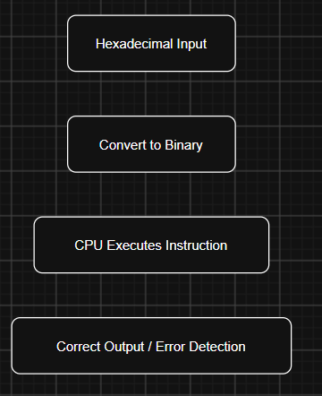

Importance of Hexadecimal and Binary Conversion
Hexadecimal is a base-16 number system that uses the digits 0–9 and the letters A–F. Each hexadecimal digit represents 4 binary bits.
Example:
- Hexadecimal: 3A
- Binary: 0011 1010
Importance
- Makes large binary numbers easier to read.
- Simplifies debugging and error detection.
- Represents memory addresses and machine instructions efficiently.
- Reduces the chance of writing long binary values incorrectly.
- Helps programmers analyze packet data quickly.

Effects of Incorrect Conversion
If a hexadecimal value is converted incorrectly into binary, the CPU may process the wrong data.
Possible effects include:
- Incorrect instruction execution.
- Wrong memory address access.
- Data corruption.
- Packet transmission errors.
- Program crashes.
- Incorrect output or system malfunction.
For example, if 3A is mistakenly interpreted as 2A, the binary value changes, causing the processor to execute a different instruction or access an incorrect memory location.

Impact on Instruction Execution
The CPU follows the Fetch–Decode–Execute cycle.
1. Fetch
The CPU fetches the instruction from memory.
2. Decode
The Control Unit decodes the binary instruction.
3. Execute
The ALU performs the required operation.
4. Store
The result is written back to memory or registers.
If the binary value is incorrect because of a conversion error, the CPU decodes and executes the wrong instruction, leading to incorrect results and reduced system reliability.

Efficient CPU Design
Modern processors include several features to improve performance and reduce errors.
1. Cache Memory
- Stores frequently used instructions and data.
- Reduces memory access time.
2. Instruction Pipelining
- Executes multiple instruction stages simultaneously.
- Increases processing speed.
3. Branch Prediction
- Predicts the next instruction to reduce delays.
- Improves execution efficiency.
4. High-Speed Buses
- Increase the speed of data transfer between CPU, memory, and I/O devices.
5. Error Detection Mechanisms
- Detect invalid data or transmission errors.
- Improve system reliability.

Role of Benchmarking
Benchmarking is the process of measuring and evaluating CPU performance using standard tests.
It helps to measure:
- Execution time.
- CPU speed.
- CPI (Cycles Per Instruction).
- Memory access time.
- Throughput.
Benefits of Benchmarking
- Identifies performance bottlenecks.
- Detects instruction execution errors.
- Evaluates processor efficiency.
- Helps compare different CPU architectures.
- Improves overall system performance.

Methods to Minimize Conversion Errors
- Verify hexadecimal-to-binary conversions carefully.
- Use automated conversion tools and software.
- Perform error checking before processing packets.
- Test communication systems regularly.
- Use efficient CPU architectures with cache memory and pipelining.
- Benchmark the system to identify and fix performance issues.

Conclusion
Hexadecimal representation simplifies debugging and communication, while binary is the format understood by the CPU. Incorrect conversion between these number systems can result in wrong instruction execution, data corruption, and communication errors. Efficient CPU design, including cache memory, pipelining, branch prediction, and high-speed buses, along with benchmarking, helps detect errors, improve performance, and ensure reliable operation in real-time data communication systems.
****

